Virtual Memory: Demand Paging and Page Replacement Algorithms

An Assignment submitted in partial fulfillment of the requirements for the degree of
Bachelor of Science
in
Computer Science

CS 2301 - Operating Systems 1
Term 4 - 2025
University of The People

May 8, 2025

Virtual Memory: Demand Paging and Page Replacement Algorithms
Introduction
In the rapidly evolving world of cloud computing, managing memory resources effectively is crucial for optimal system performance, especially for applications with variable memory demands. Virtual memory techniques, particularly demand paging, enable operating systems to load only the necessary pages of a program into memory when needed. This approach reduces physical memory usage and enhances overall system efficiency. However, the performance of demand paging is significantly influenced by the choice of page replacement algorithms, which determine how pages are managed in memory. This essay will examine the working principles of demand paging, its impact on system performance, and critically evaluate various page replacement algorithms.
1. Explain how demand paging works in virtual memory.
Demand paging is a memory management technique utilized in virtual memory systems to optimize the use of physical memory by loading only the necessary pages of a program into memory as they are accessed. Unlike traditional methods that load an entire program at startup, demand paging allows the operating system to defer the loading of pages until they are needed (Silberschatz et al., 2013). Figure 1 shows how demand paging works in virtual memory when a program is executed.
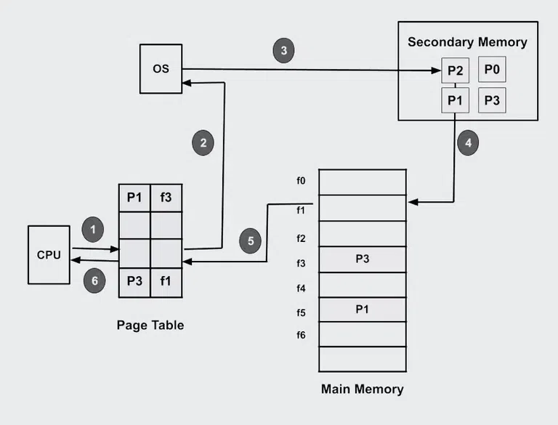
Figure 1: How demand paging works in virtual memory
Demand paging is a crucial concept in virtual memory management that allows an operating system to load pages into memory only when they are needed, rather than loading the entire program at once. GeeksforGeeks (2024) explains how demand paging works. Suppose we want to run a process P which have four pages P0, P1, P2, and P3 as shown in Figure 1. Currently, in the page table, we have pages P1 and P3:
- Step 1: Program execution: When a program is launched, the operating system allocates an initial amount of memory for it. However, this allocation does not include loading all pages into memory; instead, it prepares the environment for execution.
- Step 2: Creating page tables: The operating system maintains a structure called a page table for each process. This table keeps track of which pages of the program are currently loaded in memory and which are stored on disk.
- Step 3: Handling page faults: If the program tries to access a page that is not currently in memory (either because it hasn’t been loaded yet or it has been swapped out), a page fault occurs. The operating system pauses the program execution at this point.
- Step 4: Page fetch: Upon encountering a page fault, the operating system checks the page table to determine if the required page exists on the disk. If it does, the operating system retrieves that page from disk and loads it into an available memory space. After loading, it updates the page table to indicate the new location of the page in memory.
- Step 5: Resuming the program: Once the necessary pages have been loaded into memory, the operating system resumes the execution of the program from the point where it was interrupted.
- Step 6: Page replacement: If the memory is full and a new page needs to be loaded, the operating system must select an existing page to swap out. This is done using a page replacement algorithm that decides which page to remove based on certain criteria (like least recently used).
- Step 7: Page cleanup: When a process is finished executing, the operating system cleans up by freeing the memory that was allocated to that process and removing its entries from the page table. This ensures efficient memory management for future processes.
Demand paging allows systems to run larger applications using less physical memory, as not all pages need to be loaded simultaneously, thus optimizing resource usage. Figure 2 shows the steps in handling a page fault as described by Silberschatz et al. (2013).
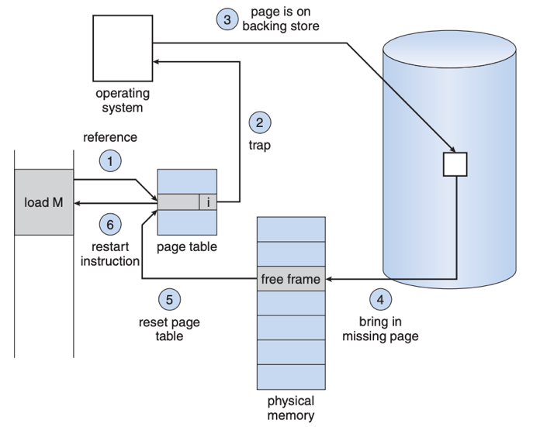
Figure 2: Steps in handling a page fault. Step 1: Check the internal table to verify the validity of the memory reference. Step 2: Terminate the process if the reference is invalid; if valid and not in memory, proceed to page it in. Step 3: Locate a free frame from the free-frame list. Step 4: Schedule a disk operation to load the page into the allocated frame. Step 5: Update the internal and page tables once the disk read is complete. Step 6: Resume the interrupted instruction, allowing access to the page as if it had always been in memory.
2. Describe the impact of demand paging on system performance in the context of the new application with variable memory demands.
The implementation of demand paging in the newly deployed application can provide significant advantages in managing variable memory demands. By leveraging virtual memory, the operating system efficiently allocates resources, allowing multiple applications to operate simultaneously. This capability effectively reduces the burden on physical memory, leading to improved overall system performance (Silberschatz et al., 2013). For instance, larger programs that require more memory can run smoothly, as demand paging permits the system to retrieve necessary pages from secondary storage only when required. Consequently, this optimizes memory utilization, ensuring that the workload is distributed effectively across available resources, which ultimately enhances the operational efficiency of our cloud services.
On the contrary, demand paging has some drawbacks that cannot be overlooked since they can adversely affect program execution. The page fault mechanism, which activates when an application requests a page not currently in physical memory, may introduce delays as the operating system retrieves the required data from secondary storage (Silberschatz et al., 2013). This process can be time-consuming, particularly in scenarios with high page fault rates, leading to potential performance degradation. However, these delays can be mitigated by optimizing the page replacement algorithm, which determines which pages to evict from memory (Silberschatz et al., 2013). By improving this algorithm, we can enhance the responsiveness of the application and reduce latency, allowing for a more seamless user experience while maintaining efficient memory management.
3. Compare the performance of four different page replacement algorithms in the provided scenario. Analyze how each algorithm influences page fault rates, and offer a critical evaluation and justification for their respective impacts on system efficiency.
Four prominent page replacement algorithms that can be applied in this scenario include: Least Recently Used (LRU), First-In-First-Out (FIFO), Optimal Page Replacement (OPT), and the Clock Algorithm. The LRU algorithm works by tracking which pages have been used most recently, replacing the least recently accessed page when a page fault occurs. Its effectiveness comes from its ability to predict future page usage based on past behavior, leading to a lower page fault rate (Silberschatz et al., 2013). Nevertheless, the FIFO algorithm replaces the oldest page in memory, which may not account for current usage patterns and can result in a higher page fault rate, particularly if an older page is frequently accessed (Silberschatz et al., 2013). The OPT algorithm, while theoretically the best, is impractical in real-world scenarios since it requires knowledge of future requests (Silberschatz et al., 2013). Therefore, it serves as a benchmark for evaluating the efficiency of other algorithms.
The Clock Algorithm offers a practical balance between efficiency and implementation complexity. It maintains a circular list of memory pages and uses a reference bit to determine which pages should be replaced. If a page's reference bit is set, it is cleared, and the algorithm moves to the next page (Silberschatz et al., 2013). This approach helps efficiently minimize page faults without requiring extensive tracking of page usage history like LRU. In a variable memory demand environment, implementing Clock can lead to improved system efficiency by reducing the overhead associated with constant page assurance. In summary, while LRU often provides the best performance in theoretical models, FIFO may underperform due to its age-based replacement, and the practical implementation of the Clock Algorithm can deliver enhanced efficiency. Therefore, careful assessment of each algorithm's impact on page fault rates is crucial for optimizing our cloud service performance.
Conclusion
Demand paging is a vital aspect of virtual memory management that significantly enhances system efficiency by loading pages only when needed. This method optimizes physical memory usage, allowing for the smooth execution of applications with varying memory demands. By implementing effective page replacement algorithms, operating systems can minimize page faults and maximize performance, ultimately improving user experience. As applications continue to grow in complexity and size, the importance of demand paging will only increase, making it essential for modern computing environments to adopt and refine these techniques for optimal resource management and system performance.

References
Arpaci-Dusseau, R. H., & Arpaci-Dusseau, A. C. (2018). Operating systems: three easy pieces (1.01 ed.). Arpaci-Dusseau Books. https://pages.cs.wisc.edu/~remzi/OSTEP/
GeeksforGeeks. (2024, July 16). What is demand paging in operating system? https://www.geeksforgeeks.org/what-is-demand-paging-in-operating-system/
Silberschatz, A., Galvin, P., & Gagne, G. (2013). Operating system concepts essentials (2nd ed.). John Wiley & Sons, Inc.

